##### Screenshots

###### Screen 1: – Provider home with address/contact information, Referral sources, Preferences and activity Log.

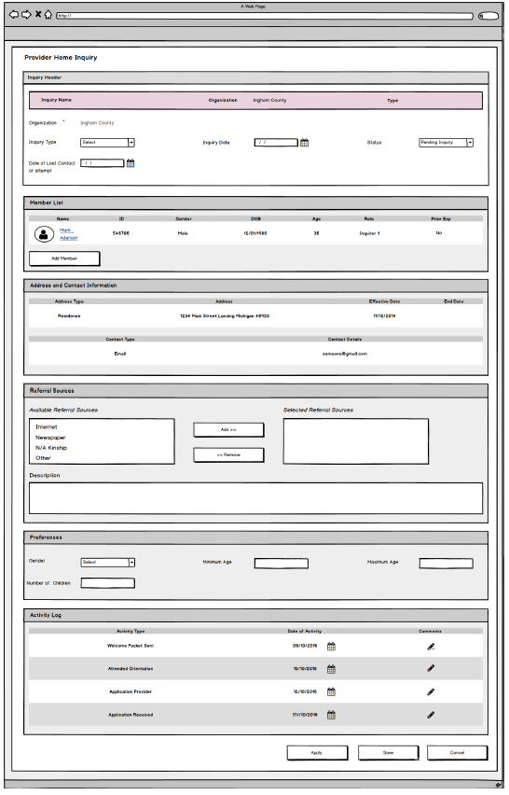

### Story

As an Inquiry Worker, I want to maintain a list of pre-assessment activities so that I can assure all pre-conditions have been met before assigning the applicant for home assessment.

**Points to Note**

N/A

**Demo Steps**

1. Login to the USFN application with the following credentials

Username: samweaver

Any Password works.

1. The My Organizer is displayed after successful login.
2. Click on the provider tab.
3. Click on the Inquiry which will navigate to Inquiry list page.
4. Click on the Add Inquiry Button then you will navigate to provider home inquiry page.

###### Screen 2: – Provider home with address/contact information

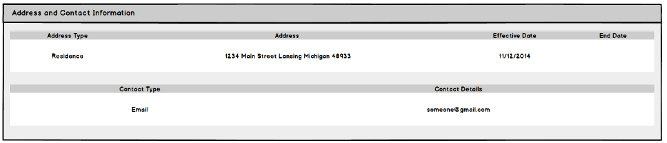

**Screen Fields: Provider Inquiry Addresses/Contacts**

| **Class.Attribute Name** | **T Display Name** | **Type** | **Align** | **Size** | **Read Only** | **Calculation** | **Edit Mask** | **To Be UI Validation** |
| --- | --- | --- | --- | --- | --- | --- | --- | --- |
| PartyAddress.partyAddressTypeCode | Type | Display text |  | N/A | T |  |  | System derived. |
| Address.streetName, Address.streetNumber, Address.cityName, Address.stateCode, Address.zip5Code | Address | Display text |  | N/A | T | Where partyAddressTypeCode = ‘Residence’ or ‘Mailing’ |  | System derived. |
| PartyAddress.beginEffDate | Effective Date | Display text |  | 10 | T |  | MM/DD/YYYY | System derived. |
| PartyAddress.endEffDate | End Date | Display text |  | 10 | T |  | MM/DD/YYYY | System derived. |
| N/A | Contact List | Group Frame |  |  |  |  |  |  |
| PartyContactMedium.contactTypeCode | Type | Display text |  | 30 | T |  |  | System derived. |
| PartyContactMedium.areaCode  PartyContactMedium.telephoneNbr  PartyContactMedium.extension  PartyContactMedium.emailAddr | Contact Details | Display text |  | N/A | T | Where partyContactMedium = ‘Home’ or ‘Email’ |  | System derived. |

**Acceptance criteria**

|  |  |  |  |
| --- | --- | --- | --- |
| # | Requirement | Execution Event | Status |
| 1. 1 | The Address information displayed in the Address List should be:  1. The Current Primary Residence address of the Inquirer 1;  2. The Current Mailing address of the Inquirer 1.visible until the Inquiry record is successfully saved. | Screen open. |  |
| 1. 2 | The only addresses listed for the Provider Home are the Primary Residence Address and the most current Mailing Address (if any) for Inquirer 1. | Screen open. |  |
|  | The only contact information listed for the Provider Home is the Primary Contact information for Inquirer 1. The current Email address will also be displayed if available. | Screen open. |  |
|  |  |  |  |

###### Screen 3: Provider home with Referral sources

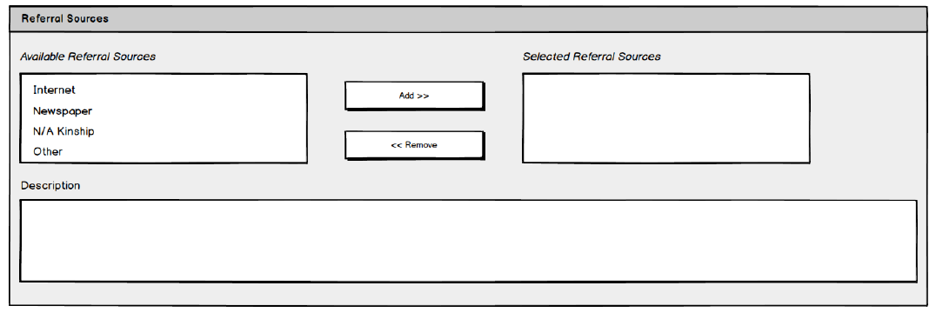

**Edit/View Provider Inquiry Detail – Referral Sources**

| **Class.Attribute Name** | **Display Name** | **Type** | **Align** | **Size** | **Read Only** | **Calculation** | **Edit Mask** | **To Be UI Validation** |
| --- | --- | --- | --- | --- | --- | --- | --- | --- |
| N/A | Referral Sources | Group header |  | N/A |  |  |  |  |
| N/A | Available Referral Sources | Mover box |  | 30 | F | **Domain Code:** RecruitmentEventType |  | User selected.  Not required.  Reference value list; all values that have not been selected. |
| InquiryReferralSource.referralSourceCode | Selected Referral Sources | Mover box |  | 30 | F |  |  | Reference value list; all values that were selected from the Available Referral Sources swap box. |
| ProviderInquiry.referralSourceDescText | Description | Text field |  | 1000 | F |  |  | User entered.  Not required. |

* + 1. Action Buttons/Hyperlinks

| **Label** | **Type** | **On Click Action/Navigation** |
| --- | --- | --- |
| Add > | Button | Moves all selected values in the Available Referral Sources swap box to the Selected Referral Sources swap box. |
| < Remove | Button | Moves all selected values in the Selected Referral Sources swap box to the Available Referral Sources swap box. |
| Link Event | Button | Display Recruitment Event page with the selection column visible. Return IDs for all events selected on that page at the time it is closed. Refresh screen with rows for the selected events. |
| Unlink | Hyperlink | Unlinks the event from the Provider inquiry |

* + 1. Reference Values

| **No.** | **Class Attribute** | **Domain Code** | **Short Desc** | **Ref Data Code** |
| --- | --- | --- | --- | --- |
| 1 | InquiryReferralSource.inquiryReferralSourceCode | RecruitmentEventType | Adoption Informational Meeting | ADOPTIONINFOMEETING |
| Business Community | BUSINESSCOMMUNITY |
| Church Event | CHURCHEVENT |
| Civic/Community Fair | CIVICCOMMFAIR |
| Community Meeting | COMMMEETING |
| Conferences | CONFERENCES |
| County Fair | COUNTYFAIR |
| Employee Contact/Groups | EMPCONTACTGRPS |
| Ethnic Festival | ETHNICFESTIVAL |
| Foster Home Conversion Info. Meeting | FHCONVMEETING |
| Hospital/Medical | HOSPITALMED |
| Job Fair | JOBFAIR |
| Mapping Default | CONVERT** |
| Media Event | MEDIAEVENT |
| Newspaper Advertisement | NEWSPAPERAD |
| Newspaper Release/Feature Story | NEWSSTORY |
| Orientation | ORIENTATION |
| Other/Documented in Text | OTHERDOC |
| Radio Advertisement | RADIOAD |
| Radio Talk Show | RADIOSHOW |
| School Contacts/Groups | SCHOOLCONTACTS |
| School/Educational | SCHOOLEDUC |
| Service Organization | SERVICEORGANIZATION |
| State Fair | STATEFAIR |
| Television Advertisement | TVAD |
| Television Talk Show | TVSHOW |
| Volunteers | VOLUNTEERS |

* + 1. Notes and Assumptions

Per the State the above Reference Values should be modified as follows:

| **No.** | **Class Attribute** | **Domain Code** | **Short Desc** | **Ref Data Code** |
| --- | --- | --- | --- | --- |
| 1 |  | RecruitmentEventType | Adoption Informational Meeting | ADOPTIONINFOMEETING |
| 2 |  | RecruitmentEventType | Conferences | CONFERENCES |
| 3 |  | RecruitmentEventType | Employee Contact/Groups | EMPCONTACTGRPS |
| 4 |  | RecruitmentEventType | Foster Home Conversion Info. Meeting | FHCONVMEETING |
| 5 |  | RecruitmentEventType | Hospital/Medical | HOSPITALMED |
| 6 |  | RecruitmentEventType | Orientation | ORIENTATION |
| 7 |  | RecruitmentEventType | School Contacts/Groups | SCHOOLCONTACTS |
| 8 |  | RecruitmentEventType | School/Educational | SCHOOLEDUC |
| 9 |  | RecruitmentEventType | Service Organization | SERVICEORGANIZATION |
| 10 |  | RecruitmentEventType | Rec - On-line/internet | RECONLINE/INTERNET |
| 11 |  | RecruitmentEventType | Rec - Billboard | RECBILLBOARD |
| 12 |  | RecruitmentEventType | Rec - Plus One Challenge | RECPLUSONECHALLENGE |
| 13 |  | RecruitmentEventType | Rec - Heart Gallery | RECHEARTGALLERY |
| 14 |  | RecruitmentEventType | Rec - Feet on the Street | RECFEETONTHESTREET |
| 15 |  | RecruitmentEventType | Rec - Kinship Festival | RECKINSHIPFESTIVAL |
| 16 |  | RecruitmentEventType | Rec - Wait No More Event | RECWAITNOMOREEVENT |
| 17 |  | RecruitmentEventType | Rec - Local Parks (partnering with DNR) | RECLOCALPARKS |
| 18 |  | RecruitmentEventType | Rec - Wendy's Wonderful Kids Golf Outing | RECWENDYSWONDERFULKIDSGOLFOUTING |
| 19 |  | RecruitmentEventType | Rec - Business Community | RECBUSINESSCOMMUNITY |
| 20 |  | RecruitmentEventType | Rec - Church Event | RECCHURCHEVENT |
| 21 |  | RecruitmentEventType | Rec - Civic/Community Fair | RECCIVICCOMMFAIR |
| 22 |  | RecruitmentEventType | Rec - County Fair | RECCOUNTYFAIR |
| 23 |  | RecruitmentEventType | Rec - Ethnic Festival | RECETHNICFESTIVAL |
| 24 |  | RecruitmentEventType | Rec - Job Fair | RECJOBFAIR |
| 25 |  | RecruitmentEventType | Rec - Media Event | RECMEDIAEVENT |
| 26 |  | RecruitmentEventType | Rec - Newspaper Advertisement | RECNEWSPAPERAD |
| 27 |  | RecruitmentEventType | Rec - Newspaper Release/Feature Story | RECNEWSSTORY |
| 28 |  | RecruitmentEventType | Rec - Other/Documented in Text | RECOTHERDOC |
| 29 |  | RecruitmentEventType | Rec - Radio Advertisement | RECRADIOAD |
| 30 |  | RecruitmentEventType | Rec - Radio Talk Show | RECRADIOSHOW |
| 31 |  | RecruitmentEventType | Rec - State Fair | RECSTATEFAIR |
| 32 |  | RecruitmentEventType | Rec - Television Advertisement | RECTVAD |
| 33 |  | RecruitmentEventType | Rec - Television Talk Show | RECTVSHOW |

###### Screen Shot: Edit/View Provider Inquiry Detail – Preferences

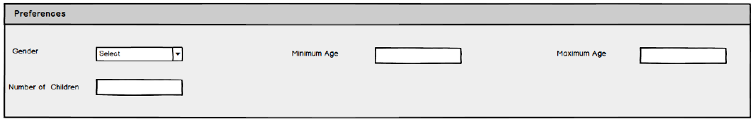

Screen Fields

| **Class.Attribute Name** | **Display Name** | **Type** | **Align** | **Size** | **Read Only** | **Calculation** | **Edit Mask** | **UI Validation** |
| --- | --- | --- | --- | --- | --- | --- | --- | --- |
| N/A | Preferences | Group header |  | N/A |  |  |  |  |
| ProviderInquiry.acceptMinAgeNbr | Minimum Age | Text field |  | 3 | F |  |  | User entered.  Not required. |
| ProviderInquiry.acceptGenderCode | Gender | Dropdown List |  | 30 | F | **Domain Code:** GenderBoth |  | Not required. |
| ProviderInquiry.acceptMaxAgeNbr | Maximum Age | Number |  | 3 | F |  |  | User entered. |
| ProviderInquiry.acceptMultipleChildrenCode | Number of children | Dropdown List |  | 1 | F | **Domain Code:** YesNo |  | User entered. |

**Acceptance criteria**

|  |  |  |  |
| --- | --- | --- | --- |
| # | Requirement | Execution Event | Status |
| 1. 1 | 0 ≤ Minimum Age ≤ Maximum Age < 21 | Save/Apply |  |

###### Screen shot: List Provider Activity

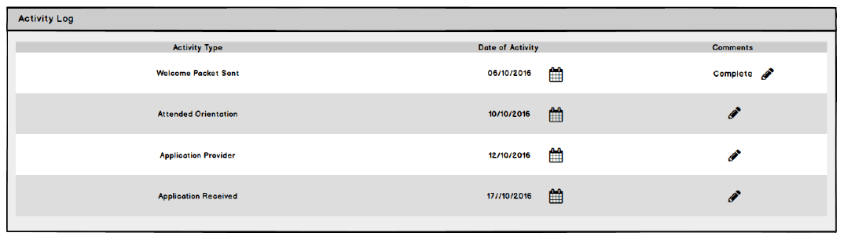

*screen fields*

| **Class.Attribute Name** | **Display Name** | **Type** | **Align** | **Size** | **Read Only** | **Calculation** | **Edit Mask** | **To Be UI Validation** |
| --- | --- | --- | --- | --- | --- | --- | --- | --- |
| N/A | Activity Log | Group Header |  |  |  |  |  |  |
| InquiryActivityLog.activityDate | Date of Activity | Display text |  | 10 | T |  | MM/DD/YYYY | System derived. |
| InquiryActivityLog.activityTypeCode | Activity Type | Display text |  | 30 | T |  |  | System derived. |
| InquiryActivityLog.activityDescText | Comments | Display text |  | 4000 | T |  |  | System derived. |

Action Buttons/Hyperlinks

| **Label** | **Type** | **On Click Action/Navigation** |
| --- | --- | --- |
| Comments | Icon | User can click on this icon and start entering the comments in the comments box. After entering the comments user can click on “”to save the comment |
| Date | Calendar icon | User can select the dates from the calendar. |
|  |  |  |

**Acceptance criteria**

|  |  |  |  |
| --- | --- | --- | --- |
| # | Requirement | Execution Event | Status |
| 1. 1 | The system must display the following four activities which should be pulled from ActivitySubCategory domain table.   * Welcome packet sent. *  Attended orientation. * Application provided. * Application received.   The remaining options should be blocked out. | Screen open |  |
| 1. 2 | The user must be able to enter the date next to each activity and as well as record his comments. | Save/Apply |  |
|  | Once all the activities date have been entered and previous conditions satisfied then only the user can change the status from pending inquiry to pending approval. | Save/Apply |  |